Apps->workflow

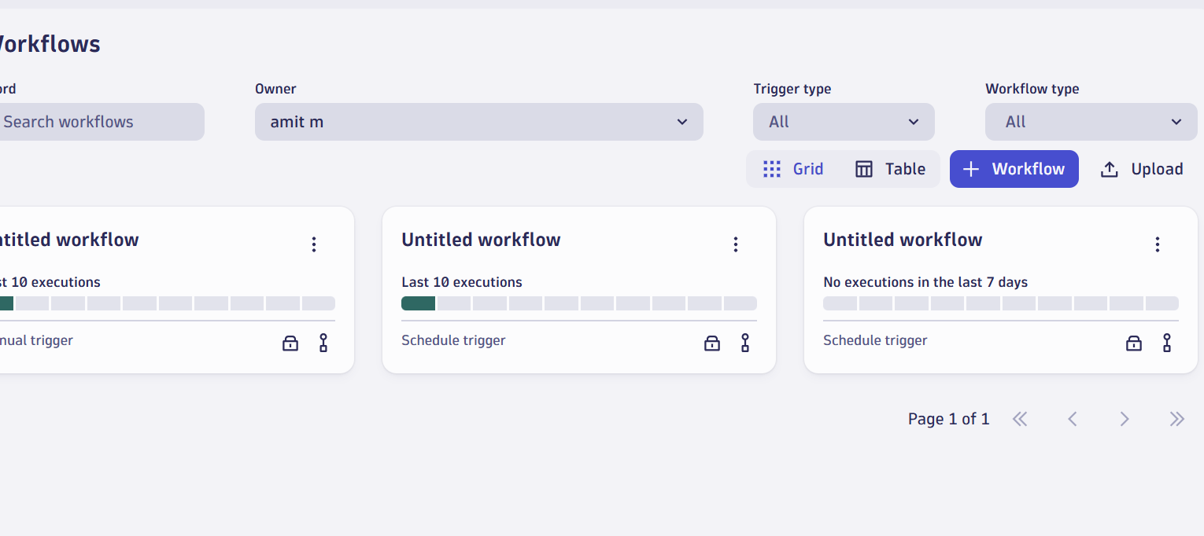

Click on Trigger

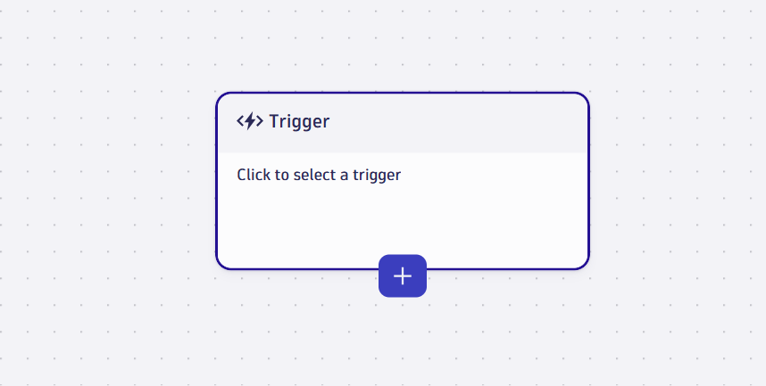

Select cron Schedule

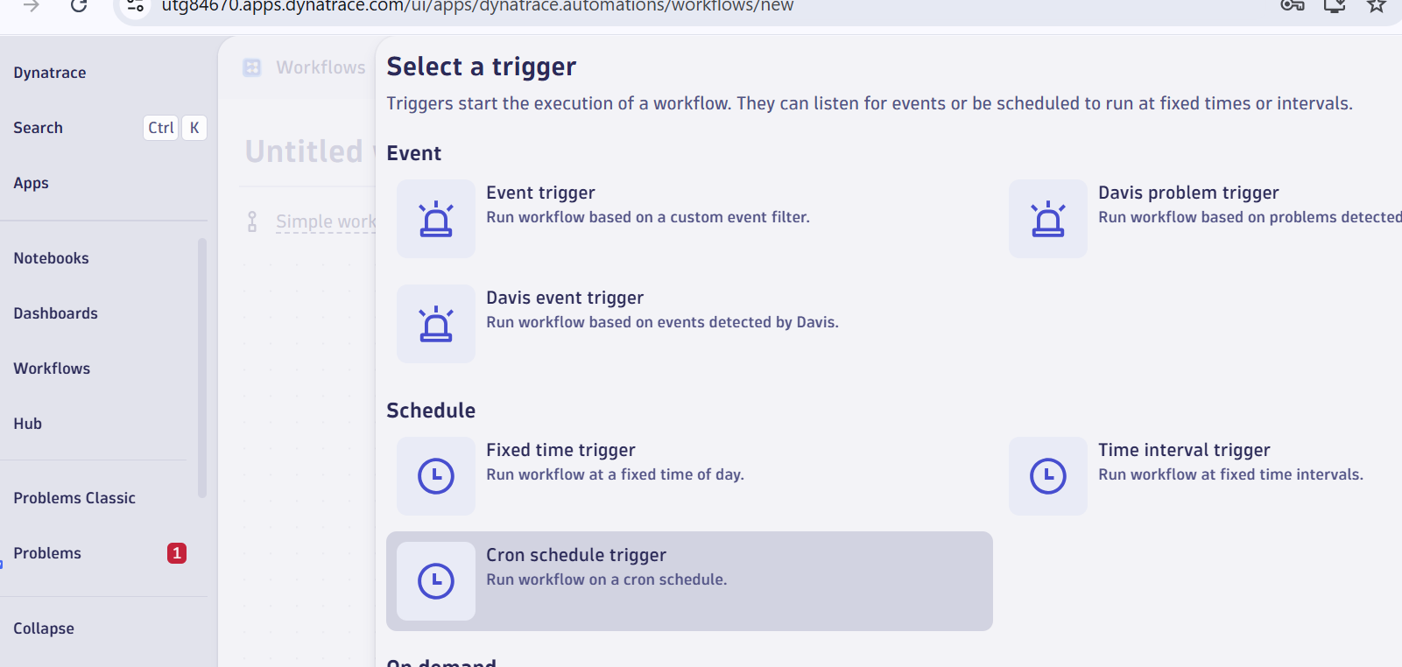

New task

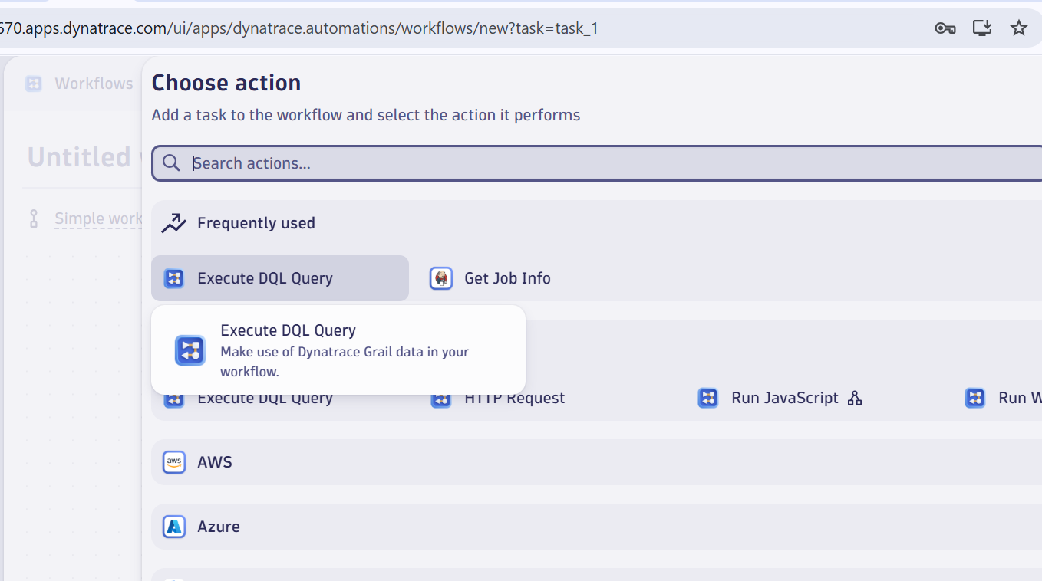

Copy this query

fetch logs

| filter NOT matchesValue(status, "WARN")

| makeTimeseries count = count()

| limit 20